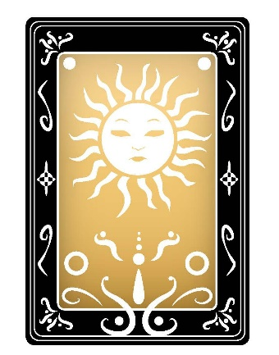
Date:
Question:
Cards Laid:

Describe your first thoughts upon looking at the cards in response to the question asked:

Elements
Fire: Wands Water: Cups Earth: Pentacles Air: Swords
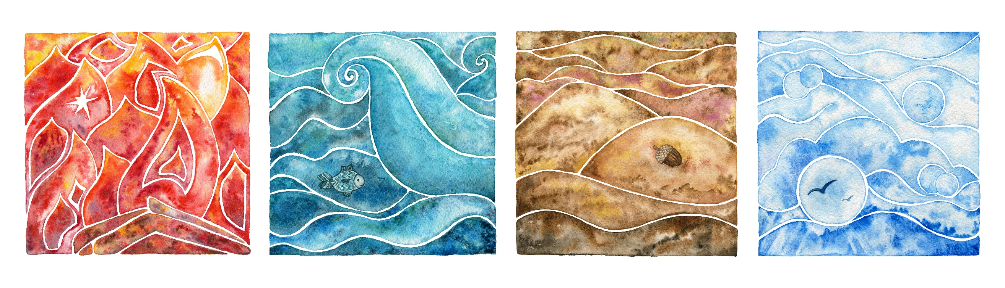
Passions- energy feelings- spiritual resources- grounded thoughts-speech
List the card’s elements below:
Card 1: Card 2: Card 3:

Is the reading elementally ‘active’ with passion, movement or speech that may bring movement or change to a situation?
Are there ‘grounding’ elements in the reading that offer reliability, security or non-movement?
Is the reading based on feelings? If so, this can signify a non-moving situation at present but it could also be indicate upcoming issues or a period of personal development.
Air cards can bring decisions and thought processes that lead to communication and change.
Describe below what you see in the reading in relation to the elements, this only needs to be general and brief.

Numerology:
Repeating numbers can highlight significant information within a reading. Odd numbers are changeable, and active and tend to represent change and movement. Even numbers can bring balance to a situation and tend to be less active.

Add the numbers of the cards together and keep adding the single digits until you arrive at one single number: example 7 + 2 + 5 = 14 and 1 + 4 = 5 so this represents the Hierophant. The Hierophant’s energy will influence the reading/situation in some way.
The reading with 7, 2 and 5 is likely to signify change, balance is sought with the ‘2’ card but with the activity of the 7 and 5 cards this potential may be affected or balance may come once everything is settled.
Add your thoughts on the number associations within your reading?

12345678910
Make notes below on any further associations that you may like to consider

Astrology

Kabbalah

Other

Your Interpretation
You may like to add an image of the reading for a visual reminder or have the cards laid out in front of you. List the card names and positions, you can also mention the deck’s name.
- Introduce your reading with your initial thoughts
- Progress with your interpretation
- Conclude your interpretation by re-visiting the question with your thoughts.

