INTERNATIONAL TAROT FOUNDATION
3 CARD SKILLS DEVELOPMENT
CERTIFICATION READINGS 1 UP TO 3
Date: Question: Cards Laid:
1.
2.
3.

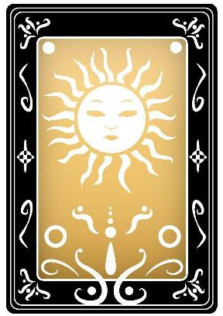

In relation to the question asked, does this lay of cards look positive or not so positive?

- Is there one element that is more dominant ( ie; an element that shows up more than once) ?

- Please name any Major Arcana cards that are in the reading.

- Please name any Minor Arcana cards that are in the reading.

- Are there more odd or even numbered cards?

Elements
Fire: Wands
Water: Cups
Earth: Pentacles
Air: Swords
Passions- energy
feelings- spiritual
resources- grounded thoughts-speech
List the card’s elements below:
Card 1: Card 2 2:nnnnn
Card 3:

Your Interpretation
You may like to add an image of the reading for a visual reminder or have the cards laid out in front of you. List the card names and positions, you can also mention the deck’s name.
You can follow the example above for your format, or do as you prefer.

